Chemical and Physical Characterisation of Reactively Extracted Rapeseeds: Effect of Particle Size (300-500µm and 1000-1400µm)
Yilong Ren, Adam Harvey, Rabitah Zakaria
School of Chemical Engineering and Advanced Materials, University of Newcastle upon Tyne, UK
- Abstract
Carbohydrates, lipids and protein are the main chemical components of rapeseeds. In general, lipids and their derivatives are the only useful products extracted from rapeseed. However, it is very important to understand which chemical components remain after the oil extraction and to investigate the possibility of deriving additional value from these chemical components. Currently, worldwide there is a large amount of waste associated with rapeseed biodiesel production. Therefore, it is very important to develop new processes and/or new technology to process this waste, but they must be flexible processes and technologies, as they will have to cope with variations in feedstock, whilst responding to the needs of both current and new end-users.
One possible intensified method of biodiesel production is reactive extraction, in which, rather than the conventional crushing and solvent extraction process to produce oil followed by reaction to biodiesel, macerated seeds are contacted directly with the methanol and catalyst to produce the biodiesel directly.
The aim of this project is to study the chemical and physical properties of the various chemicals in biodiesel production by reactive extraction of rapeseed. In this paper the physical, morphological and chemical properties of the rapeseed itself during reactive extraction are investigated. The morphology and chemistry of rapeseed particles, particularly the cell structures, in the size ranges 300-500µm and 1000-1400µm were observed by means of light microscopy and SEM, with staining for lipids and carbohydrates. It was observed that the carbohydrate remains in the cell during the extraction. Lipids, as expected, were demonstrated to be largely removed, but this is a function of particle size: larger particle sizes exhibit central areas in which oil remains after extraction. This is also a function of time and morphology. The samples here were reactively extracted for 1h. The effect of time is the subject of an ongoing investigation. Seed coat particles were chemically and morphologically unaffected by the reactive extraction process, meaning that antioxidants remain in the seed-cake, so the viability of their extraction from this phase should be investigated.
Keywords: biodiesel, in situ transesterification, rapeseed, biorefinery

- Results
2.1 300-500µm particle size
    - SEM
2.1.1.1 Cotyledon particles
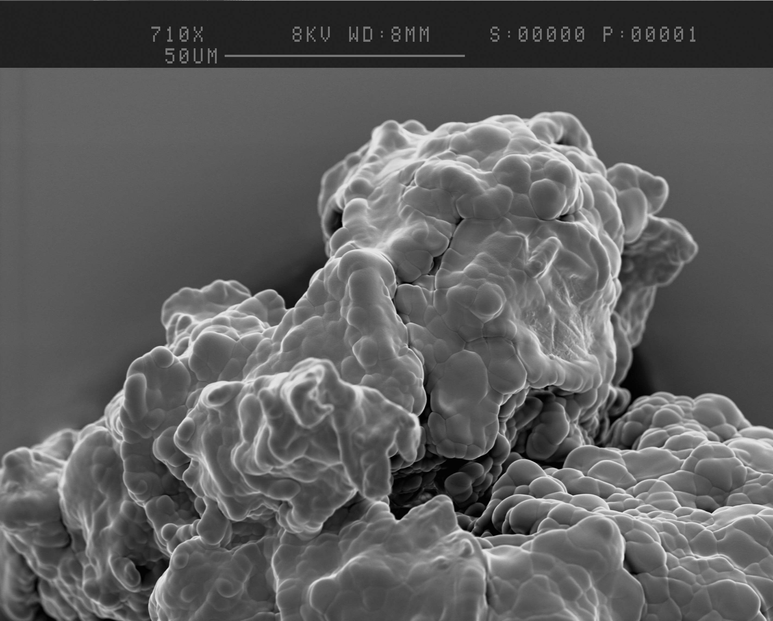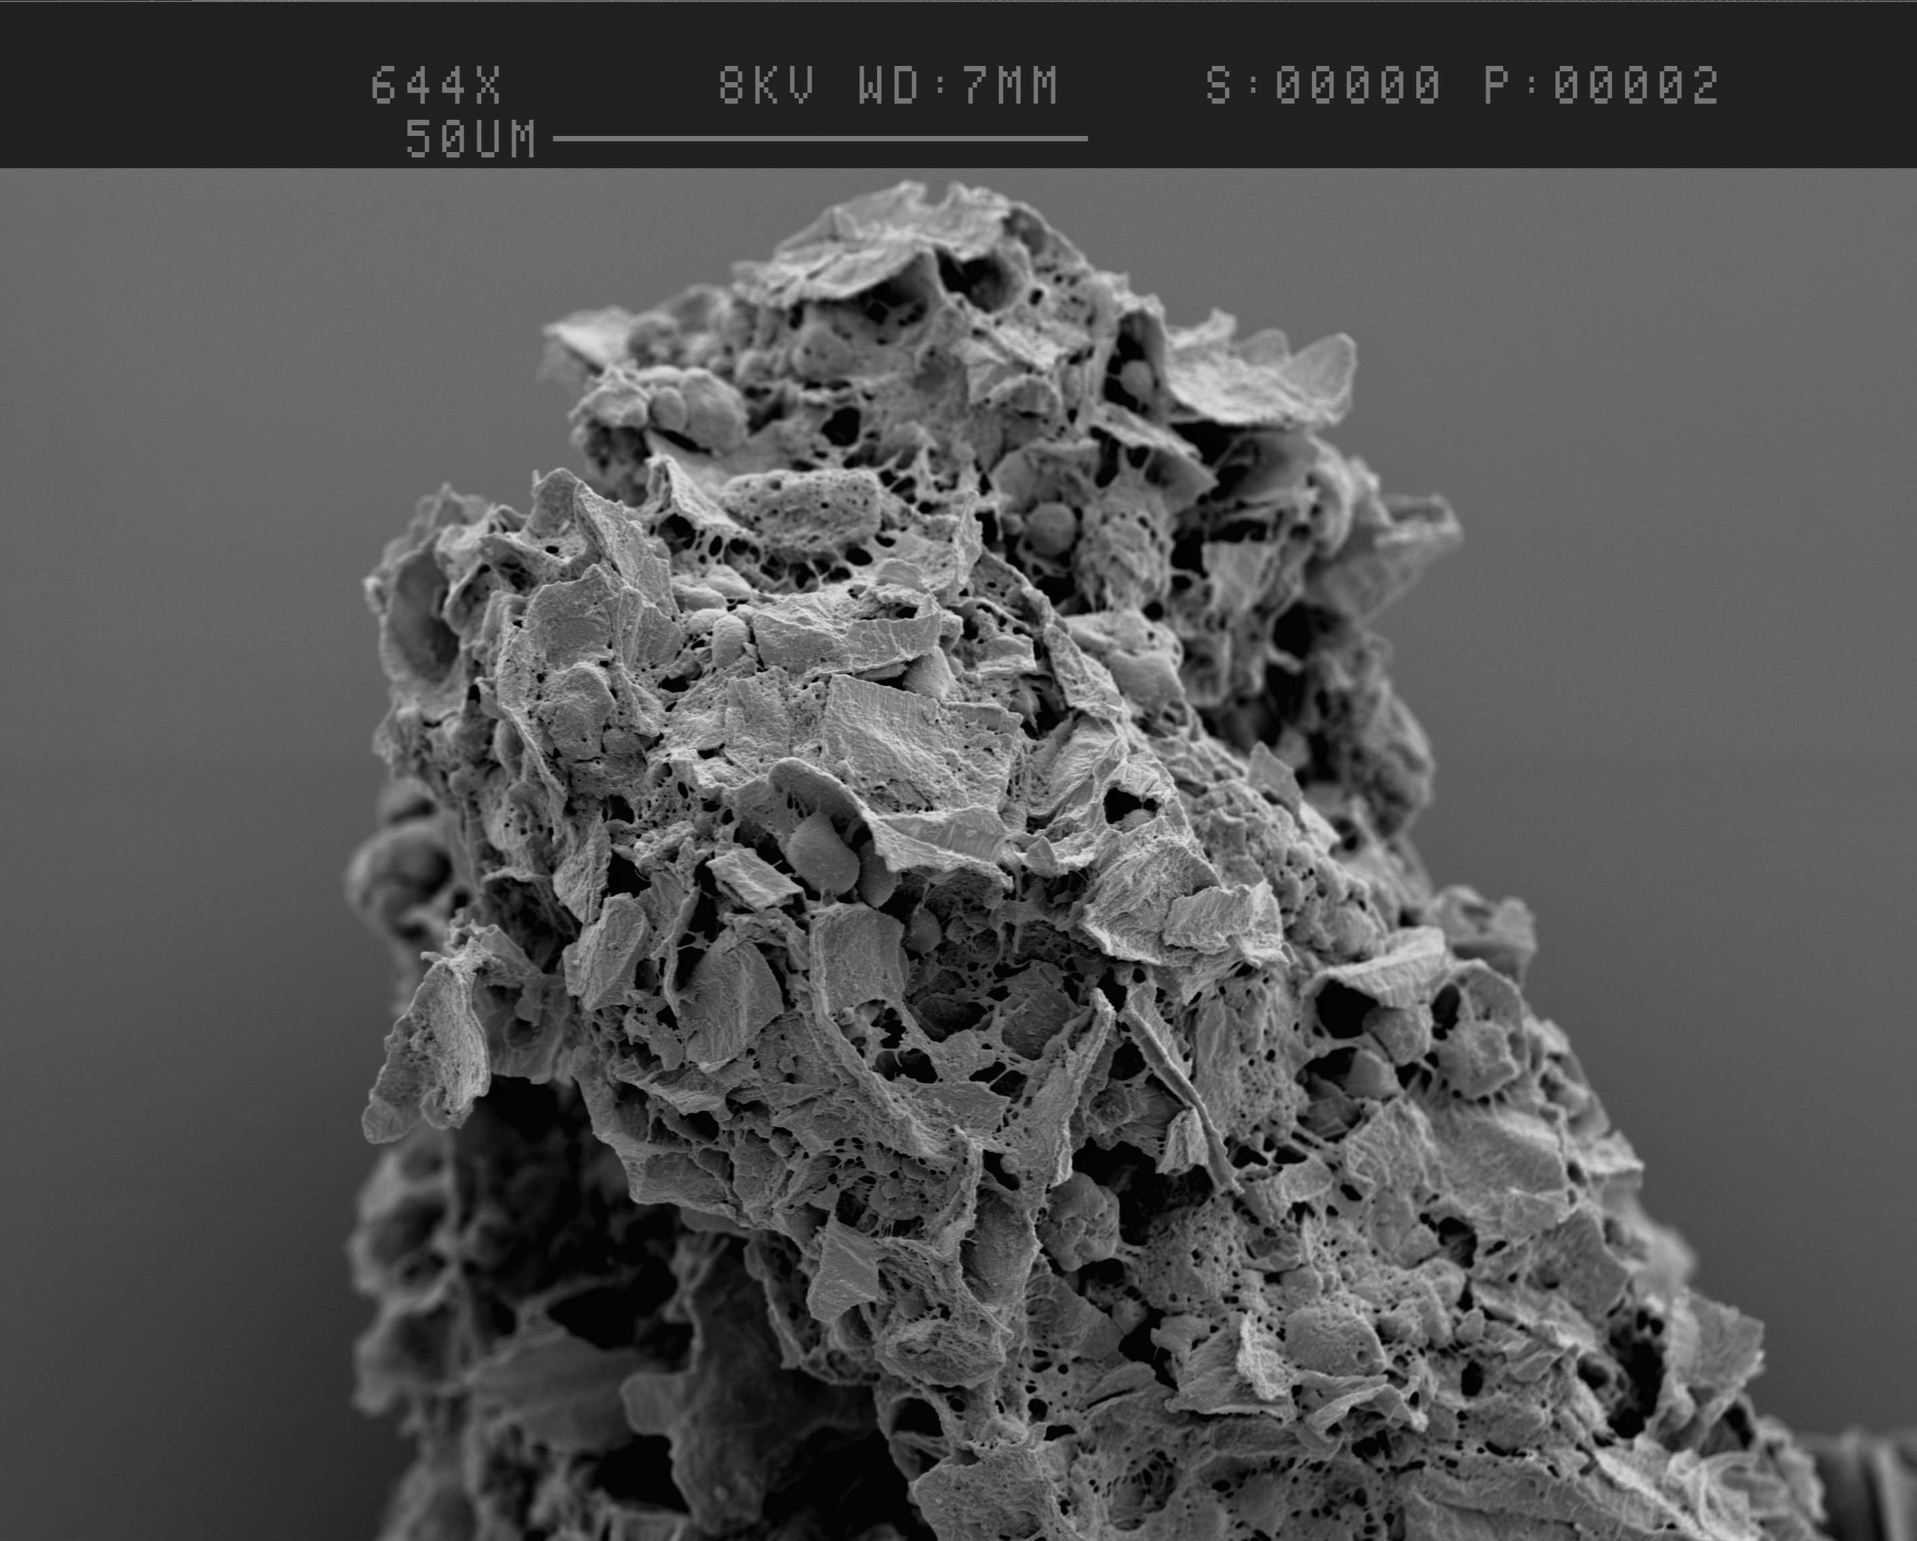
1-B
1-A
- Figure 1-A shows cotyledon particles of rapeseed before the reactive extraction of biodiesel. The lipids cover the entire surface of the particle.
- Figure 1-B illustrates the same particle after 1 hour reactive extraction of biodiesel. The lipid seems all removed by the reactive extraction, only cell wall materials were left here.

2.1.1.2 Seed coat particles
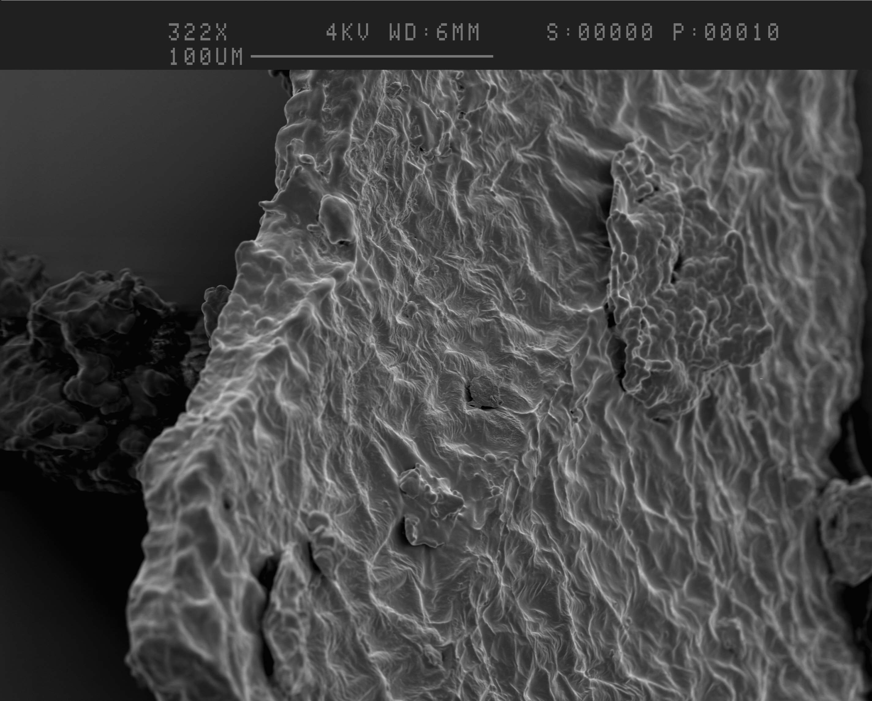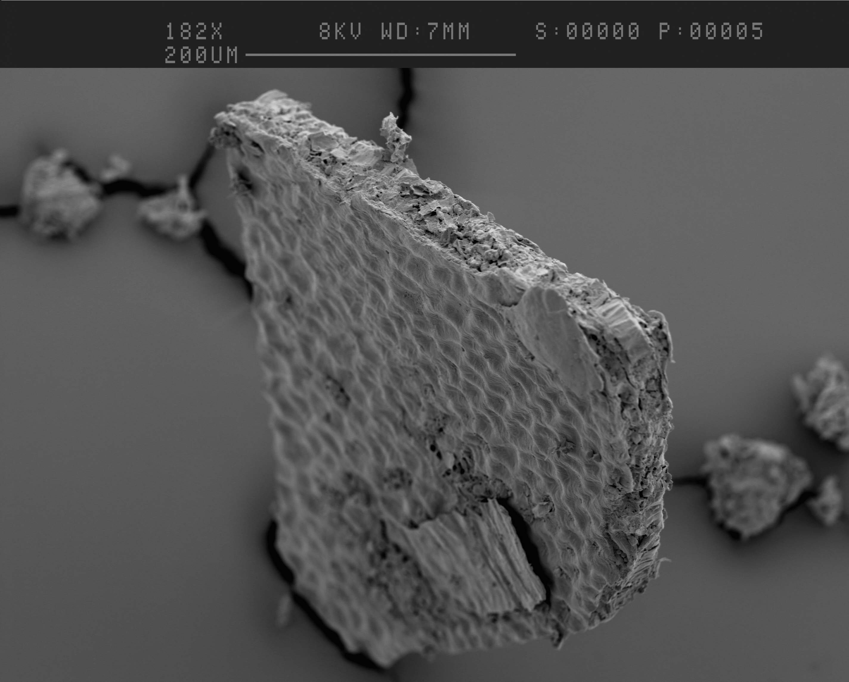
2-B
2-A

- Figure 2-A and 2-B show the seed coat fracture before and after oil extraction. There was no morphological alteration during the 1 hour reactive extraction of biodiesel.

    - Light microscope results
2.1.2.1 Cotyledon particles
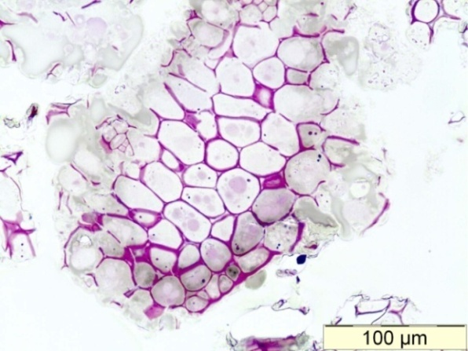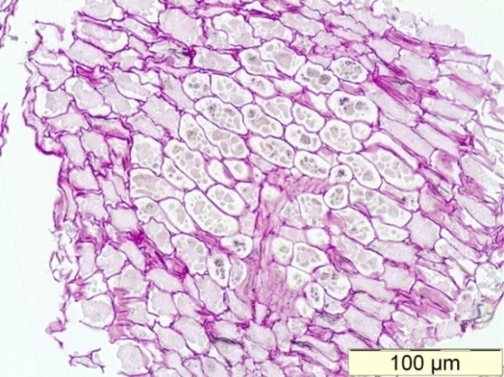
3-B
3-A
- Figure 3-A and 3-B, which were stained by periodic acid Schiff reaction (PAS); the PAS is used to demonstrate the presence of carbohydrates in the plant tissue. The carbohydrates will be stained in pink or red colour.
- Figure 3-A and 3-B shows the particle before and after the 1 hour reactive extraction of biodiesel, respectively. In each image, carbohydrates were stain in pink which were cell wall material here.
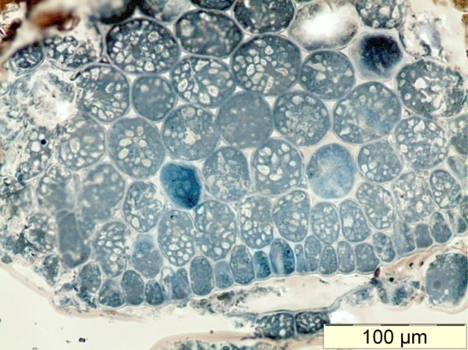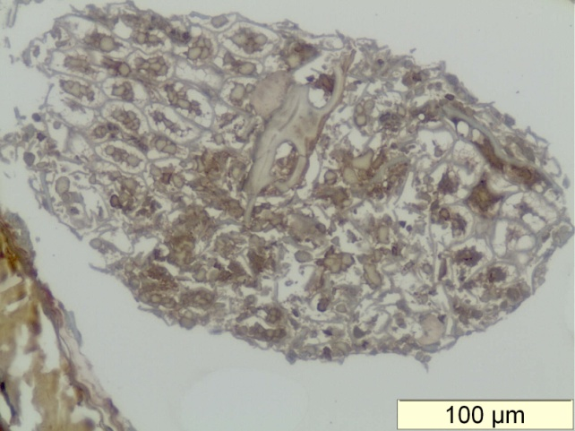
4-B
4-A
- Figure 4-A and 4-B show the rapeseed sections were stained with Sudan Black B, this stain is a standard marker for lipids in biological tissue.
- Figure 4-A was the rapeseed section before the reactive extraction of biodiesel. In this image, the lipids were located the inside the cell (the blue colour indicated the lipids exist).
- Figure 4-B shows the rapeseed section after the reactive extraction of biodiesel. There is not any lipids left inside the rapeseed cell, the oil seems all removed by reactive extraction.

2.1.2.2 Seed coat particles
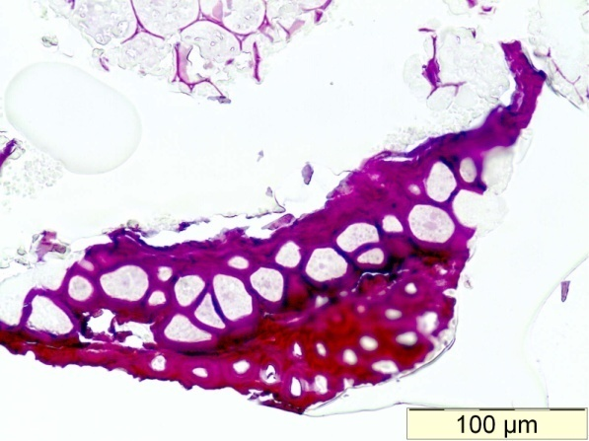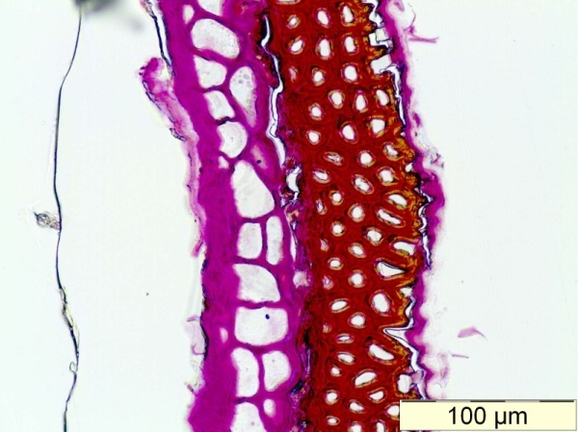
5-B
5-A
- Figure 5-A and 5-B shows the rape seed coat before and after oil extraction, respectively; and both sections were stained with PSA. Carbohydrates in the seed coat were not affected by the oil extraction. PAS results show a good agreement with SEM results.

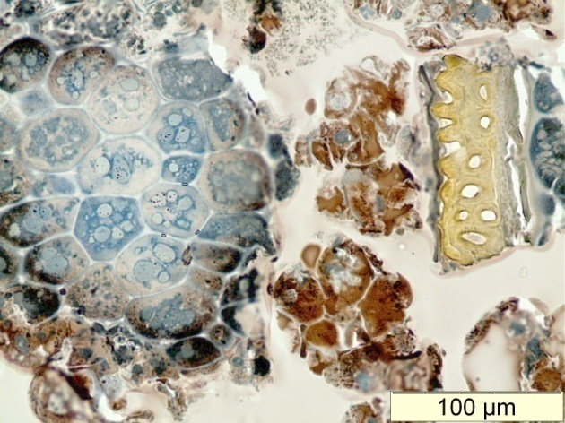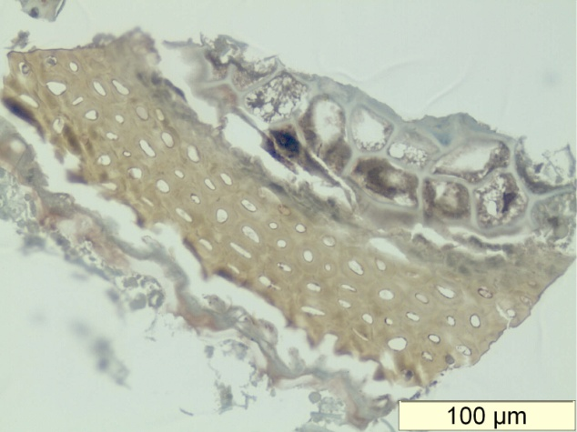
6-B
6-A
- Figure 6-A and 6-B show the section of rapeseed particles before and after oil extraction, respectively. These sections were stained by Sudan black B.
- The arrow shows the seed coat before (6-A) and after (6-B) oil extraction, there were no chemical changes after reactive extraction of biodiesel.

2.2 1-1.4mm particle size (Cotyledon of rapeseed)
2.2.1 SEM results
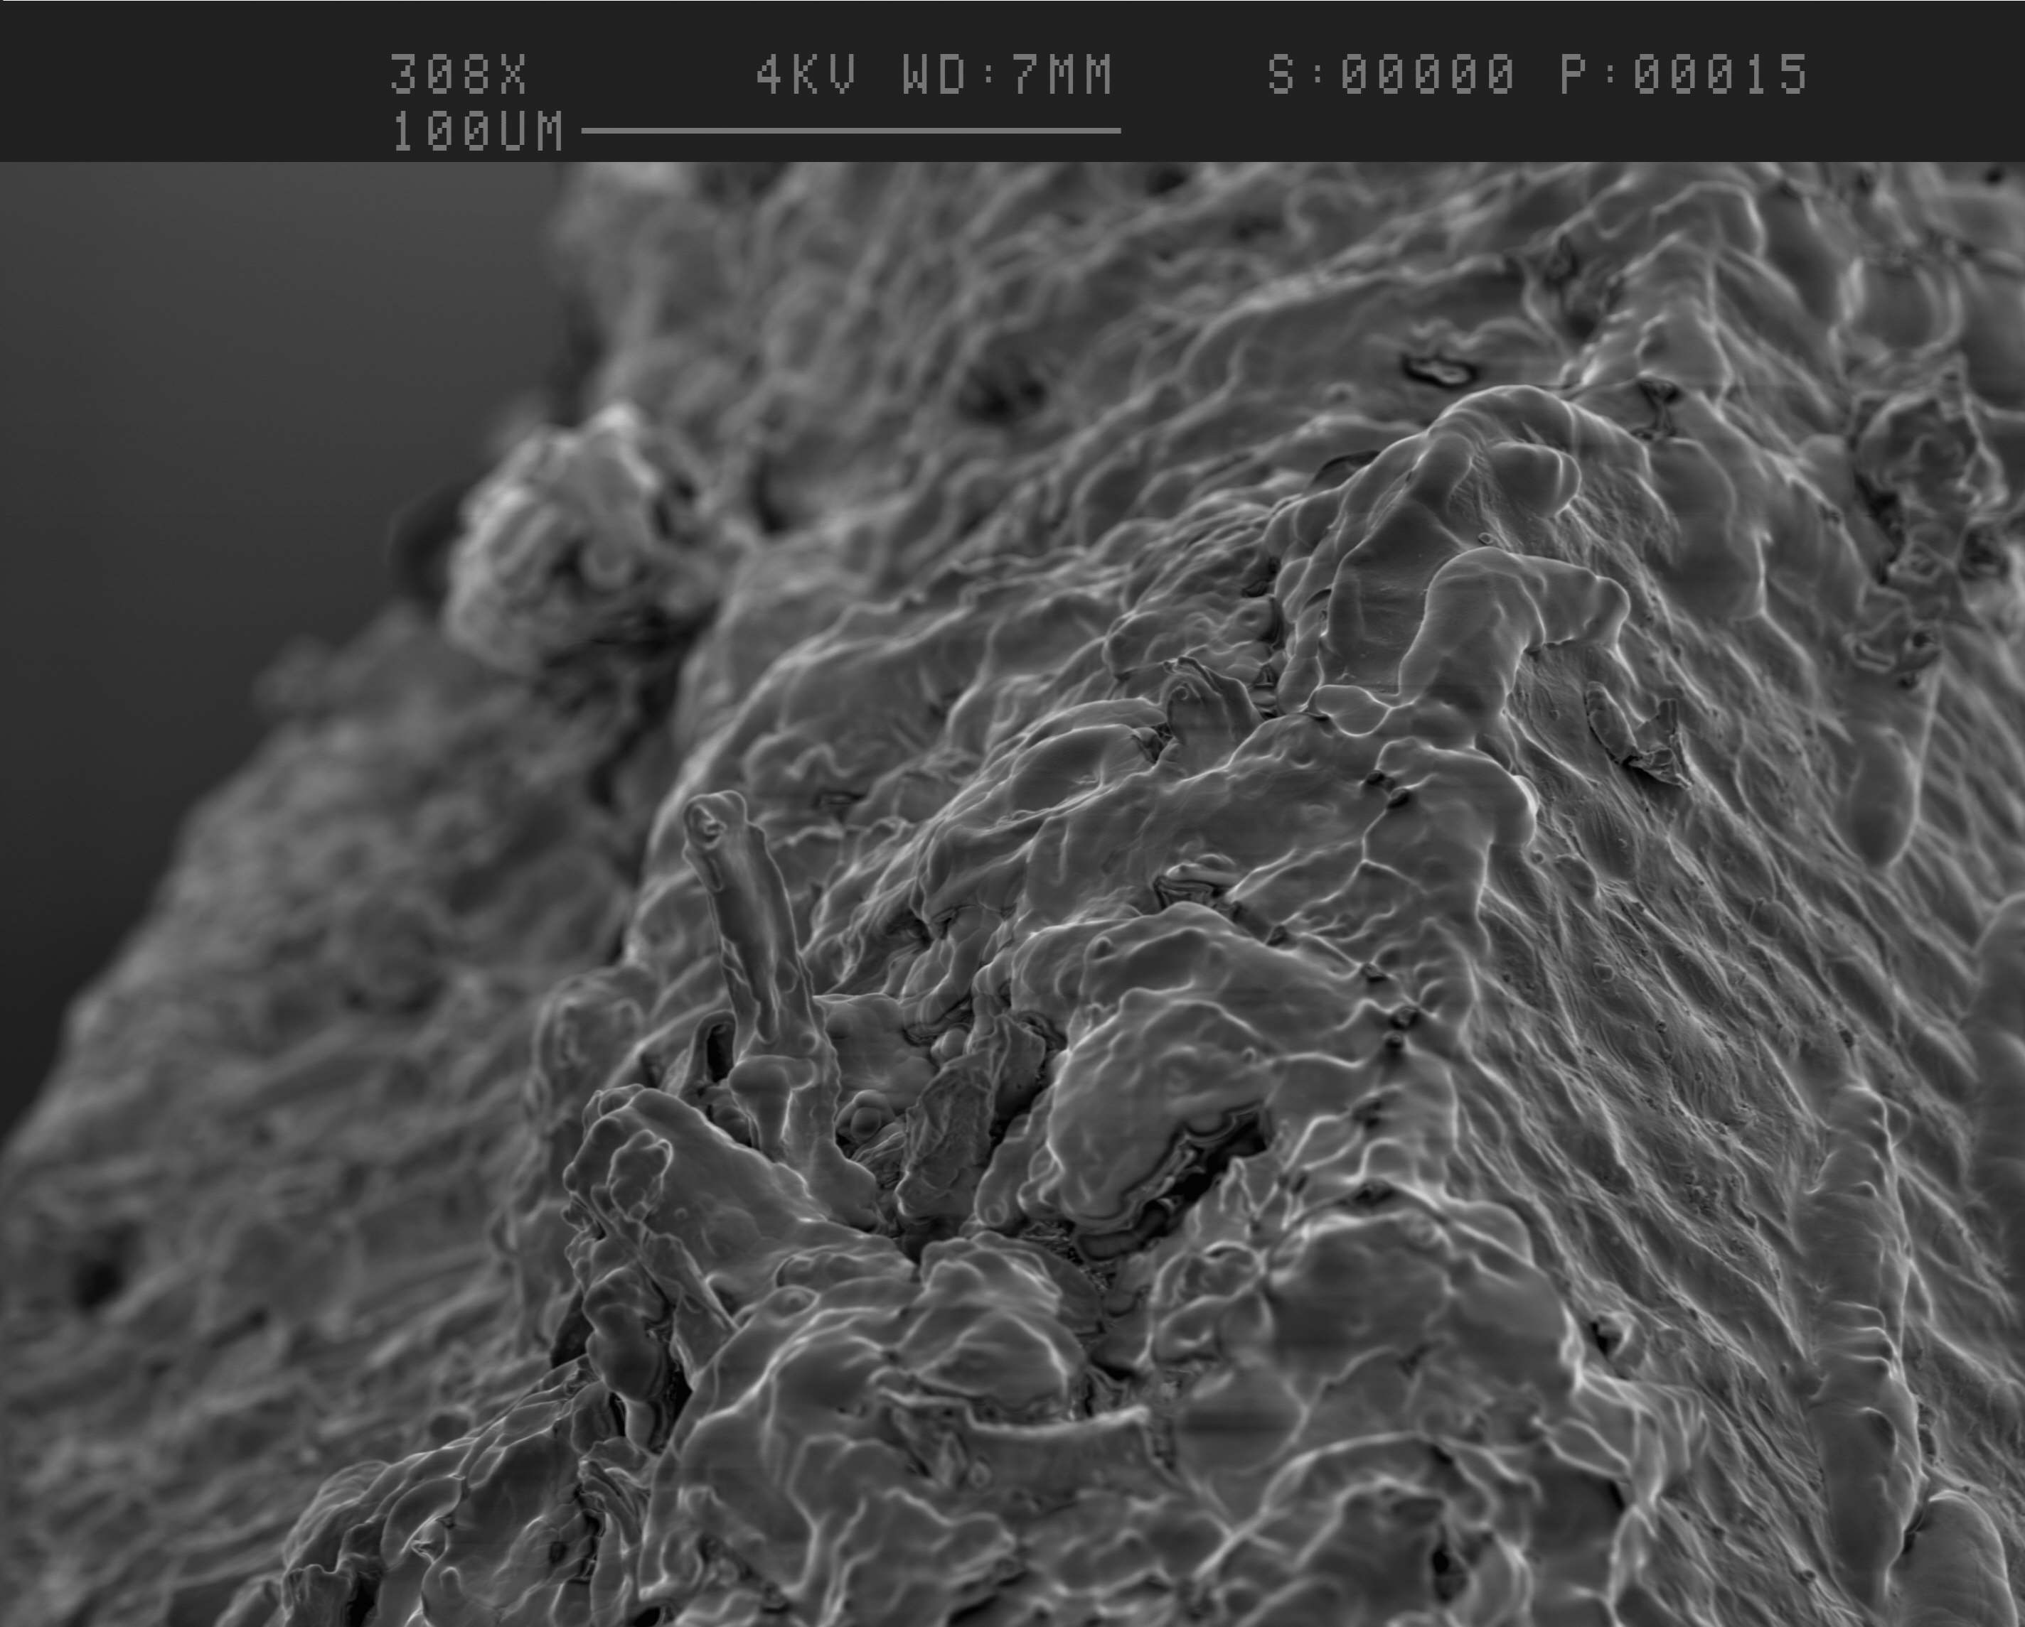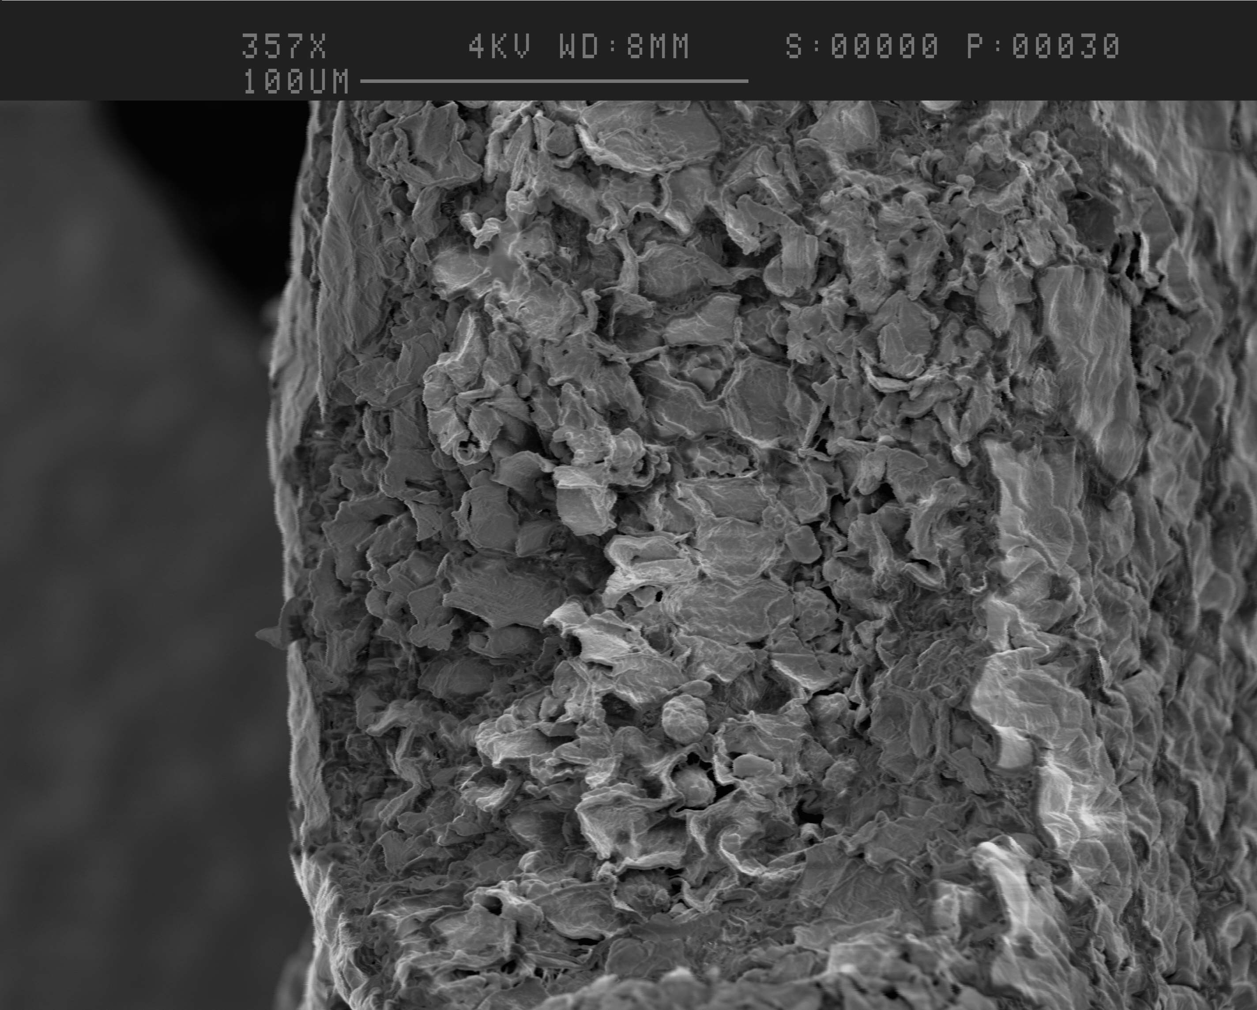
7-A
7-B
- Figure 7-A and 7-B show the bigger particle size (1-1.4mm) of rapeseed under SEM observation.
- In figure 7-A show that lipids still covered all the surface area of this particle, in contrast, after oil extraction (Figure 7-B) there was no lipids remained in the surface of rapeseed particle. However, the oil extraction seems not as good as small particles (1-B), because figure 7-B does not show very clear cell wall fractures as it is in Figure 1-B.
2.2.2 Light microscope results

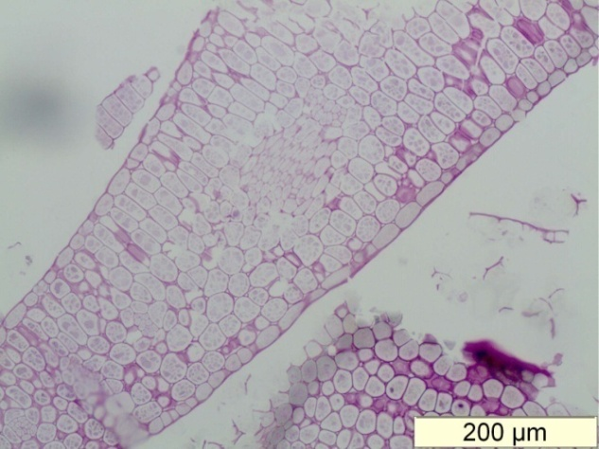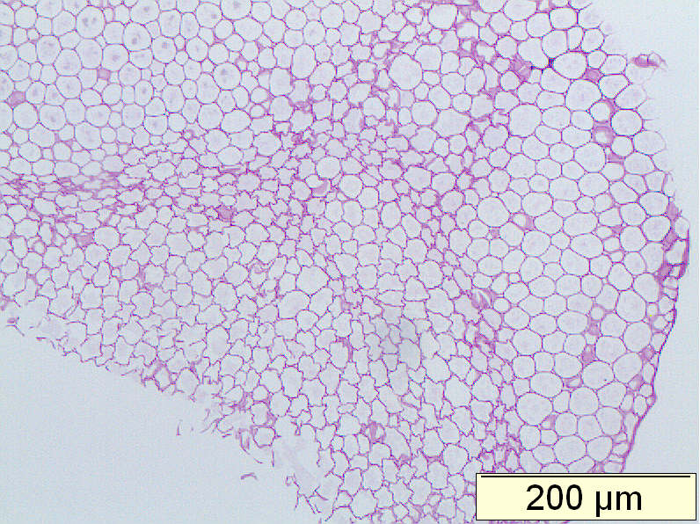
8-B
8-A
- Figure 8-A and 8-B show the rapeseed sections were stained by PAS before and after oil extraction, respectively.
- The results show that carbohydrates in the rapeseed particles were still remained in the cell wall before and after oil extaction. These results is in a very good agremment with 300-500um particles.
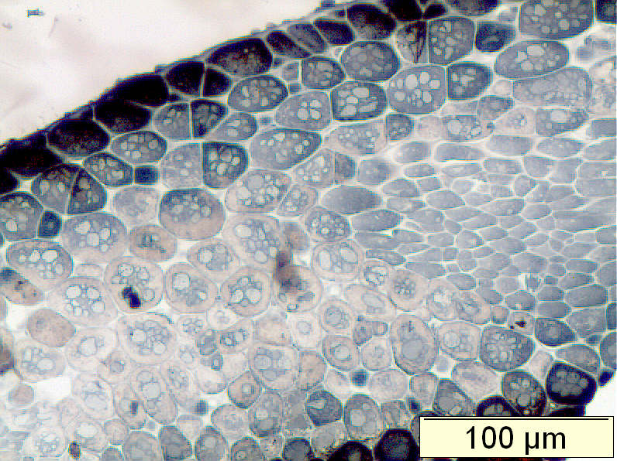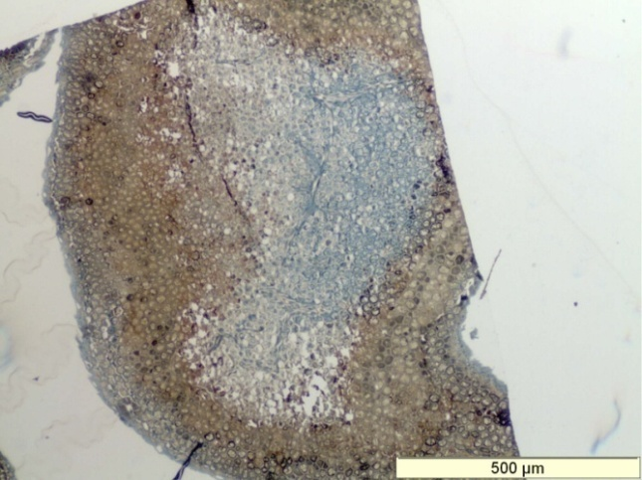
9-B
9-A
- Figure 9-A and 9-B show the rapeseed sections were stained by Sudan Black B.
- Figur 9-A show the rapeseed particle before the oil extraction, the lipids were located inside the rapeseed cotyledon cell.
- Figure 9-B show that particle was after oil extraction. It is very interesting to observe that lipids were only removed from out side area of the particles, But there were still some oil remaning in the centre of the particles, the blue stainning show the oil present inside the rapeseed cell.

- Summary

- The carbohydrates seems not effected by the 1 hour reactive extraction of bidiesel production in cotyledon and seed coat of rapeseed particle size at 300-500um and 1-1.4mm. It is possible to be recovery from seed cake.

- All the lipids were removed from 300-500um the cotyledon particles size after 1 hour reactive extraction. However, in particle size 1-1.4mm, some lipds still remain in the centre of the particles. There is no lipids in the seed coat.

- Generally, the antioxidant componds were found in most seed coat, for example, Almomd seed. This research show that chemical properties in rapeseed’s seed coat does not affect during the reactive extration of biodiesel production. Therefore, the antioxidant components can also be extracted from the seed cake.

- Future work

- Modelling the kinetics of reactive extraction of biodiesel prodution from rapeseed particles.
- Comparision the reactive extraction of biodisesel production with solvent extraction methods, for example, 1 hour methnal extraction without the sodium hydroxside, 1 hour hexane extraction.
- Chemical analysis of the rapeseed particles before and after oil extraction, for example, carbohydrates, protein and lipids alteration before and after oil extraction.

